# NAAN MUDHALVAN PROJECT REPORT

## On

**“Identifying Patterns and Trends in Campus**

**Placement Data using Machine Learning”**

Submitted in partial fulfilment of the requirements for the award of the degree of

#### Bachelor of Science

#### In

**Computer Science**

Submitted by **Team Leader**

Malini M (Reg.No. 20201371506116)

**Team Members**

Dharani S (Reg.No. 20201371506105)

Sathya S (Reg.No. 20201371506134)

Shalini S (Reg.No. 20201371506136)

Rajeshwari M (Reg.No. 20201371506129)



Department of Computer Science,

Government Arts and science college for women, Alangulam, Tenkasi – 627 851

April-2023

**Table of Contents**

#### INTRODUCTION

* 1. Overview
  2. Purpose

#### Problem Definition & Design Thinking

* 1. Empathy Map
  2. Ideation & brainstorming map screenshot

#### RESULT

Final findings (Output) of the project along with screenshots

**4.** **ADVANTAGE**

**5. APPLICATION**

**6. CONCLUSION**

**7. FUTURE SCOPE**

**8. FUTURE WORK**

**9. APPENDIX**

1. **Introduction**

**Overview**

Identifying patterns and trends in campus placement data using machine learning involves the use of algorithms and statistical models to extract insight from large datasets of placement records. The objective of this process is to identify employability of students.

The process involves several steps, including data collection, data cleaning and preparation, feature engineering, model selection, training and testing, and finally, interpretation of the results. Data collection involves gathering information on the placement records of students, including their academic performance, job preferences, and the companies they were placed in.

#### Purpose

#### 

The purpose of identifying patterns and trends in campus placement data using machine learnin is to gain insights into the factors that contribute to successful campus placements and to improve the overall quality of placements. By analyzing large datasets of placement records, institutions can identify patterns and trends in the data that can be used to enhance the employability of students.

#### By identifying the factors that contribute to successful placements, institutions can develop strategies to improve the quality of placements and ensure that students are placed in jobs that are aligned with their skills and preferences.

#### By using machine learning to analyze placement data, institutions can make data-driven decisions that are based on objective insights rather than anecdotal evidence.

#### By improving the quality of placements and enhancing the employability of students, institutions can increase student satisfaction and retention.

### 2.Problem Definition & Design Thinking

#### Empathy Map

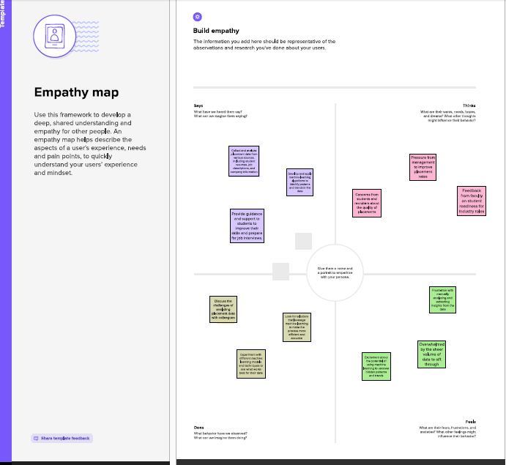

* 1. **Ideation & Brainstorming map screenshot**

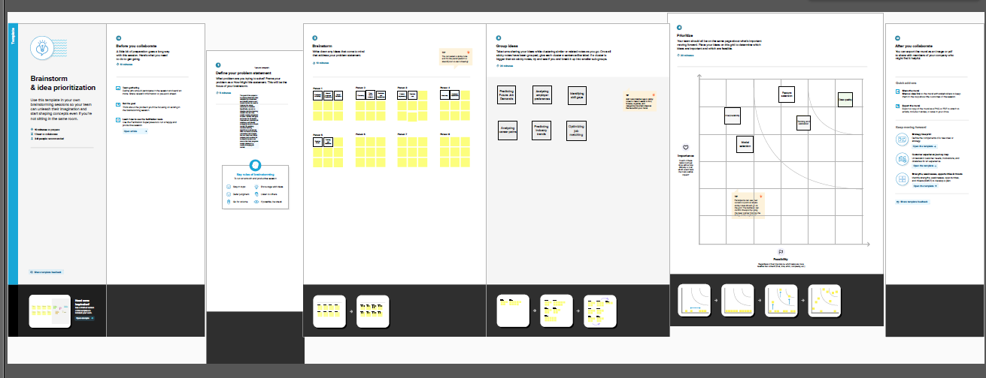

## 3.RESULT

Home page will look this

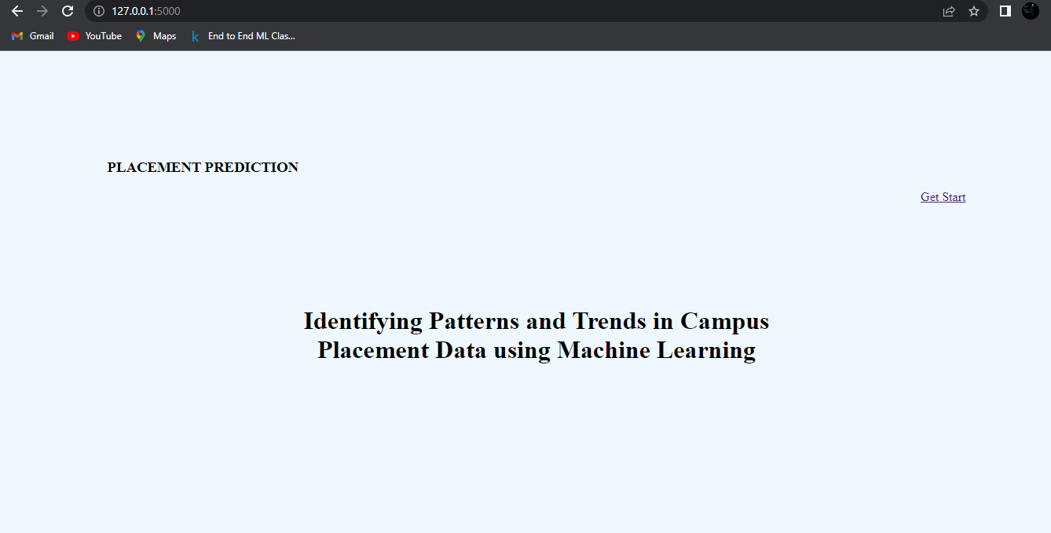

Predict page

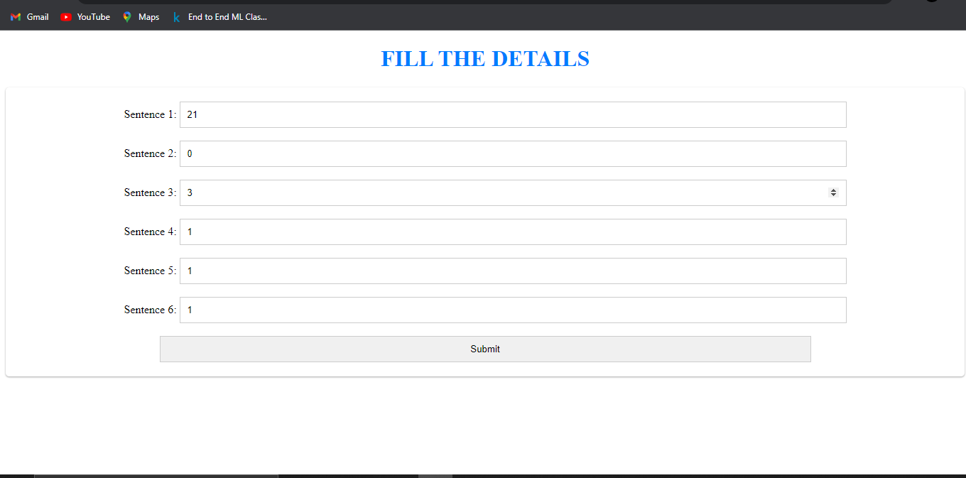

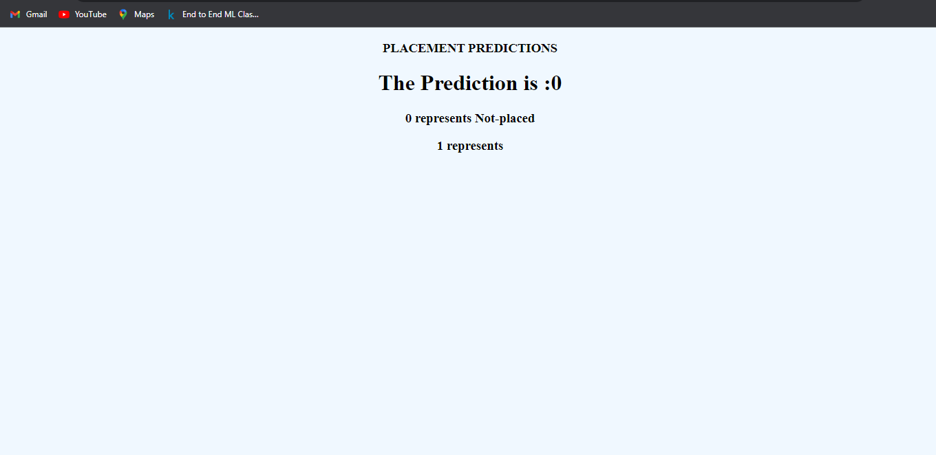

## 4.ADVANTAGE

## 

## By analyzing placement data, machine learning algorithms can identify the key factors that affect hiring outcomes, such as candidate qualifications, job requirements, and industry trends. This information can help recruiters make more informed hiring decisions and identify the most suitable for specific roles.

## Machine learning can automate the process of analyze placement data, making it faster and more efficient.

## By identifying patterns in placement data, machine learning can help organizations understand why certain candidates are more likely to stay with the company long term.

## CONCLUSION

Identifying patterns and trends in campus placement data using machine learning can provide several benefits to organizations, including improved hiring decisions, increased efficiency, better retention rates, improved diversity and inclusion, and predictive analytics. By analyzing historical placement data, machine learning algorithms can identify key factors that affect hiring outcomes, and help

organizations make more informed and strategic hiring decisions. This can lead to a more successful and diverse workforce, as well as a more efficient and effective hiring process. Therefore, organizations should consider leveraging machine learning to analyze their placement data and gain valuable insights into their hiring practices.

## FUTURE SCOPE

## A future development is the use of natural language processing (NLP) to analyze resumes and job descriptions. NLP can help identify keywords and pharses that are commonly used in job positing and resumes, allowing recruiters to better match candidates with specific job requirements.

## Predictive analytics ti forecast future hiring needs and trends. By analyzing historical data, machine learning algorithms can identify patterns and trends that can help organizations anticipate future hiring needs and develop strategies to attract and retain top talent.

## FUTURE WORK

## Developing algoriths that can analyze unstructured data

## Integrating multiple data source

## Improving the accurancy of predictions

## Ensurung fairness and transparency

## Developing personalized requirement strategies